**20151029 Secure Power Cycle and Reboot Control (IOT)**

All server administrators periodically find it necessary to power cycle a server.

Increasingly operators find it necessary to complete the reboot task remotely. The Internet provides the ubiquitous medium to complete this process. This project will demonstrate a remote power switch capability with enhanced security. Security is currently a high priority problem with IOT applications. This project will display an encrypted interface using HTTPS as well as a SSH interface.

The goal is to keep the interface simple and provide tight secure coupling between the internet client and the actual power switch. As shown in the diagram below, access to the actual power switching circuit will be accomplished through a proxy server which will be connected to the internet. Only the proxy server will have access to the control software on the local network. A encrypted login and password will be used to access the switch through the proxy server. The web server will always make a keyed request for a security key within a 20 second timing window. The originating client needs to able to respond within that 20 second window. The response key will be based on the time-of-day. A combination of the login, password and response key will allow the power switch to be pulsed for 5 seconds. More than 3 failed attempts in a 2 minute interval will generate an automatic lockout for 30 minutes. The relays used for the switch will be Normally Closed (NC). A trigger from the controller will open the circuit for 5 seconds.

This project will use 4 separate power circuits.

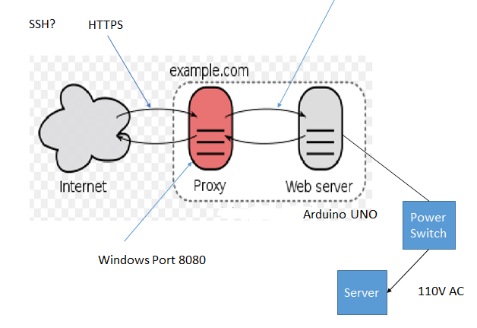

**Circuit Diagram**

PS 1 to PS 4 are relays used to switch the hot AC connection. The relay normally closed connections are used in a manner that allows the circuit to be interrupted for a few seconds to interrupt power to a load. Regular 110 volt outlets are used. This circuit support 4 power circuits. the hot side of the outlet is split to allow for 2 separate connections on each outlet.

